Roll No.:2503a52531
Name:B.Poojitha
Batch:18
Question 6: Few-Shot Prompting (Even or Odd Classification with
Validation)
Write a few-shot prompt by providing multiple input-output
examples to guide the AI in generating a Python program that
determines whether a given number is even or odd, including proper
input validation.
Examples:
• Input: 8 → Output: Even
• Input: 15 → Output: Odd
• Input: 0 → Output: Even
Task:
• Analyze how examples improve input handling and output
clarity.
• Test the program with negative numbers and non-integer inputs.

Prompt:
Generate a Python program to classify a number as Even or Odd. Use these examples: 8 → Even, 15 → Odd, 0 → Even. Validate the input and handle negative and non-integer values properly.

Code:
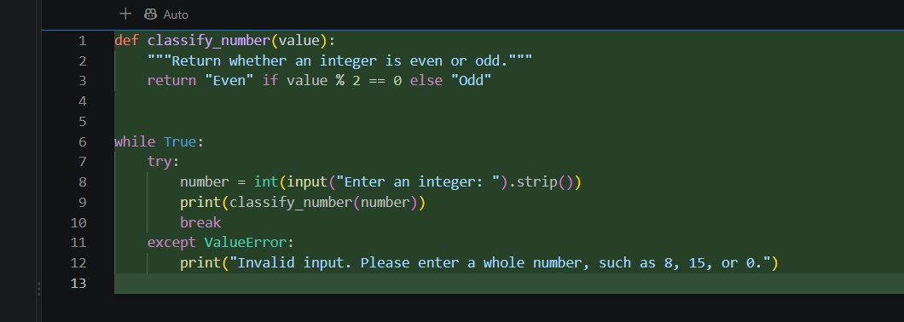

Output:
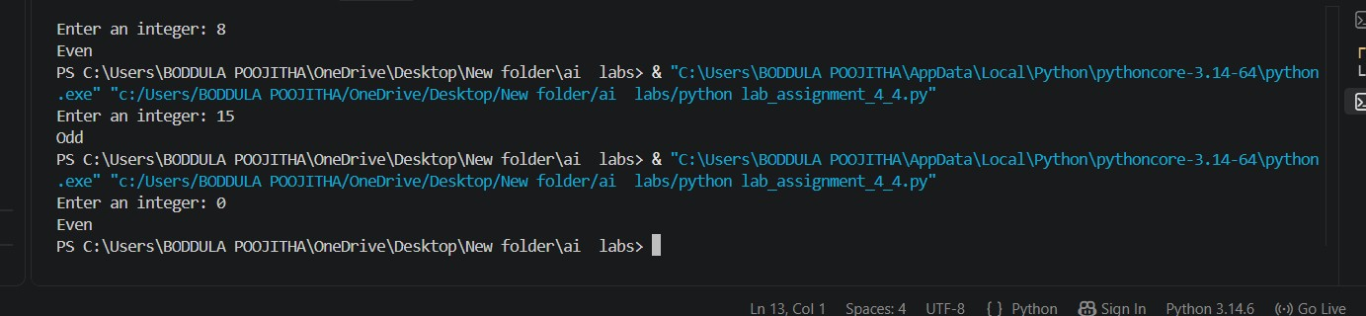

Observations:
1. The few-shot prompt generated a Python program to determine whether a number is Even or Odd.
2. The given examples helped the AI understand the expected output clearly.
3. The program correctly classified 8 as Even, 15 as Odd, and 0 as Even.
4. Proper input validation was included to handle invalid inputs.
5. Negative numbers were tested and correctly classified as Even or Odd.

